Dr. Juliette Mallison - Hainbundstraße 15 - D-37085 Göttingen

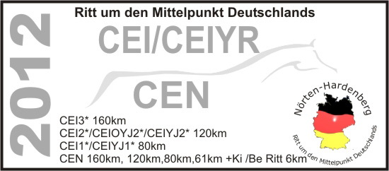

15.05.2012 – JM/ve

CEIs, CEIOYJ2*;CEIYJs ,CENs in Nörten – Hardenberg, 29.06.-01.07.2012.

Dear Sirs/Madam,

On behalf of the O.C., “AG Mitteldeutschland-Distanz“, we should like to invite competitors from your country to take part in this event.

The terrain is similar to that of Mont le Soie in Belgium where the EM for Juniors and Young Riders is being held on 08.09.2012. For this reason we are holding a CEIOYR 2* 120km, so that Young Riders and Juniors can have the opportunity to gain experience in riding as a team. A team will consist of 4 riders and horses with the 3 best to count for the team ranking. The CEIYJ2* 120km is also one of the last opportunities to qualify Young Riders and Juniors for the EM in Mont le Soie in September.

The schedules for the event are being sent with this letter. The following international/national competitions are scheduled: Please let the OC know if your riders require special invitations from the OC in order to obtain a visa for Germany.

30.06.2012 | all riders | CEI3*, CEN 160 km
 |  | CEI2*, CEIYJ2*, CEIOYJ2*
 |  | CEN 120 km
 |  | CEI1*, CEIYJ1*, CEN 90 km
 |  | CEN 61 km

The event takes place in Nörten - Hardenberg, a small town to the north of the University town of Göttingen. There is a central Vet Gate with 4 different coloured loops. The tracks are mainly grass and forest tracks. The going is firm to hard, passing through the hilly countryside around Nörten-Hardenberg. National rides are being held parallel to the CEIs. In addition, on Sunday 01.07.2012, there will be a children’s ride and a ride for handicapped riders over a distance of c. 8km. Perhaps your children would like to take part. More information can be found on the web-site www.endurance-hardenberg.de .Please could you fill in a separate form which is attached or can be downloaded from the web-site to the O.C. giving details of you, your horse, the facilities you require etc. Meals will be provided on site as from 29.06.2012, midday. The CEI Rides are also part of the GEC (German Endurance Cup) see www.endurance-timing.info.

Please send in your entries through your FN to the German Federation to H. Bergmann szahel@fn-dokr.de , Tel.0049-2581-6362260.

We wish you a safe journey. If you have any questions don’t hesitate to ask us.

With best wishes

Dr. Juliette Mallison

